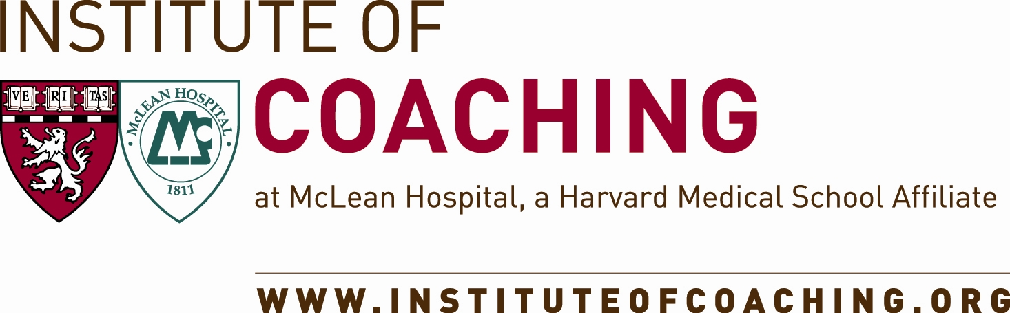

**CONTACT: FOR IMMEDIATE RELEASE**

Marcia Norris

415-526-1603

[marcia@coactive.com](mailto:marcia@coactive.com)

www.coactive.com/pressroom

To view this release online, <http://www.thecoaches.com/pressroom/institute-of-coaching-release>

**Coaches Training Institute Announces Strategic Partnership with Institute of Coaching at McLean Hospital,**

**a Harvard Medical School Affiliate**

*Projects to demonstrate the scientific validity of Co-Active Coaching*

SAN RAFAEL, CA, June 19, 2012 – One of the world’s foremost organizations in training people to build powerful relationships has announced its own most strategic partnership to date. [The Coaches Training Institute](http://www.thecoaches.com) (CTI), the oldest and largest in-person coach training school in the world, is joining forces with [The Institute of Coaching](http://www.instituteofcoaching.org) at McLean Hospital, an affiliate of Harvard Medical School, to bring the art and practice of coaching together with the science that supports its efficacy.

“This relationship between CTI and the Institute of Coaching is unique in the history of the coaching profession,” says Karen Kimsey-House, co-founder and CEO of CTI. “We’ve known intuitively and by watching results for twenty years that the Co-Active Model is an effective approach to coaching, and now, with this partnership, we’ll be able to demonstrate that through scientific research.”

The Institute of Coaching, established in early 2009, is a nonprofit organization dedicated to enhancing the integrity and credibility of the coaching profession by bridging science and best coaching practices. The Institute advances research by awarding $100,000 a year in Harnisch Grants for coaching research projects.

Indeed, the Institute will identify psychological research that supports the Co-Active Model. In fact, Kimsey-House and Dr. Carol Kauffman, Founding Director of the Institute of Coaching, will co-present a workshop, “Mapping Science to the Art and Practice of Co-Active Coaching”, at the Institute of Coaching’s annual [Coaching in Leadership & Healthcare Conference](http://www.instituteofcoaching.org/index.cfm?page=conference2012), September 28-29 in Boston.

“This is a ground-breaking, pivotal moment in the coaching industry,” says Margaret Moore, Co-Director of the Institute of Coaching. “The curricula of coach training schools in the U.S. are not always grounded in science, and yet both coaches and their clients want to know that there is a scientific foundation for their work together. The Institute can fill this gap. This is an enormous opportunity to use the science of coaching to raise the bar for the whole profession and widen the appeal for coaching.”

“CTI offers a gold standard of coach training and we know the Co-Active Model behind it can stand up to scientific scrutiny and is congruent with positive psychology,” adds Kauffman. “It’s the most tangible and powerful expression of the spirit of coaching I know. Our organizations have a beautiful, inspirational fit. It’s a marriage of compatible and synergistic values and mission.”

CTI’s students and graduates will also benefit by being able to join at a discount the Institute’s global coaching community, the [Institute of Coaching Professional Association](http://www.instituteofcoaching.org/) (ICPA).

# # #

**Key Partner Bios**

**Karen Kimsey-House, MFA, CPCC, MCC**, is the Co-founder and CEO of The Coaches Training Institute (CTI), the foremost coach training school in the world. One of the earliest recognized luminaries in the coaching profession, she founded CTI in 1992 with Laura Whitworth and Henry Kimsey-House. They created the Co-Active philosophy to relationship that informs CTI’s coaching and leadership programs. Kimsey-House is the co-author of the best-seller in the industry, *Co-Active Coaching*, and continues to lead CTI workshops and is a popular keynote speaker around the world.

**Dr. Carol Kauffman**, co-founder and co-director of the Institute of Coaching, is a leadership coach who for the past 25 years has taught at Harvard Medical School as an Assistant Professor. She is also the Founding Director of the Institute of Coaching. In 2009, she received a two million dollar award to create the Institute and its Centers of Excellence. Dr. Kauffman has launched and is the Chair of the annual Harvard Coaching Conference and the annual International Coaching Research Forum.

**Margaret Moore, MBA**, co-founder and co-director of the Institute of Coaching, is also co-director of the annual Coaching in Leadership & Healthcare conference offered by Harvard Medical School. She is a 17-year veteran of the biotechnology industry, prior to founding Wellcoaches Corporation in 2000, a School of Coaching for health professionals. She co-authored the Coaching Psychology Manual published by Lippincott, Williams & Wilkins, a Harvard Health Book “Organize Your Mind, Organize Your Life,” translating the neuroscience of brain organization into self-coaching solutions and co-authored a Harvard Medical School course on physician coaching competencies for weight management.

**About The Coaches Training Institute (CTI) and Co-Active®**

CTI is the oldest and largest in-person coach training school and one of the most innovative leadership training organizations in the world. With 35,000 students trained and courses provided in 24 countries, CTI was founded in 1992 by Karen and Henry Kimsey-House and Laura Whitworth. They developed the Co-Active Model that encompasses a philosophy, a methodology, a skill set and a communication form that balances self-awareness, relationship intelligence and courageous action so that people can be deeply fulfilled, connected to others and successful in what matters most. The foundation of all of CTI’s training, the Co-Active Model is being applied in business, education, medicine, government, communities and families around the world. CTI’s world headquarters are in San Rafael, California. [www.thecoaches.com](http://www.thecoaches.com) 1-800-691-6008

**About the Institute of Coaching**

Established in early 2009, the [Institute of Coaching](http://www.instituteofcoaching.org) is a nonprofit organization dedicated to enhancing the integrity and credibility of the coaching profession by bridging science and best coaching practices.

The Institute advances research by awarding $100,000 a year in Harnisch Grants for coaching research projects. Our annual Coaching in Leadership & Healthcare conference offered by Harvard Medical School allows coaches to learn from world-class leaders.

We have also built a global coaching community, the Institute of Coaching Professional Association ( ICPA), which brings together professionals and leaders in the field to disseminate coaching best practices based on a scientific backbone needed to validate this powerful tool for human transformation and growth.